#1. WAP to subtract a number from another number and display the result.
Code:
#include <stdio.h>
int main()
{
printf("provide the numbers you want to subtract respectively\n");
float a426,b426,c426;
scanf("%f%f",&a426,&b426);
c426=a426-b426;
printf("the result %f-%f=%f",a426,b426,c426);
return 0;
}

Output:
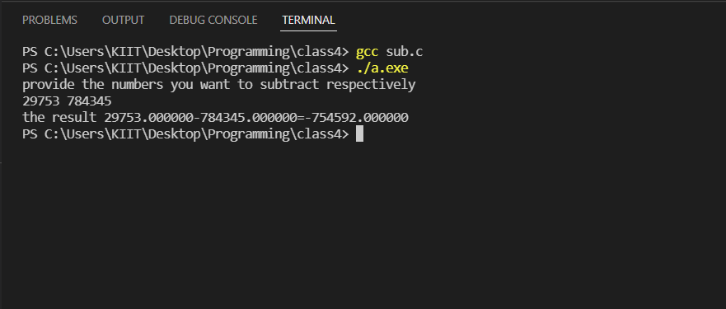

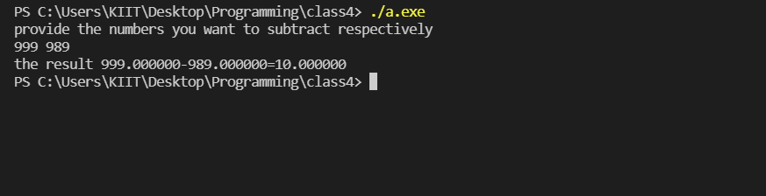

#2. WAP to convert temperature from centigrade to Fahrenheit scale.
Code:
#include <stdio.h>
int main()
{
printf("Please provide the temperature in celisius\n");
float cel426;
float far426;
scanf("%f",&cel426);
far426=(1.8*cel426)+32;
printf("%f degree celisius is %f degree farenheit\n",cel426,far426);
return 0;
}

Output:
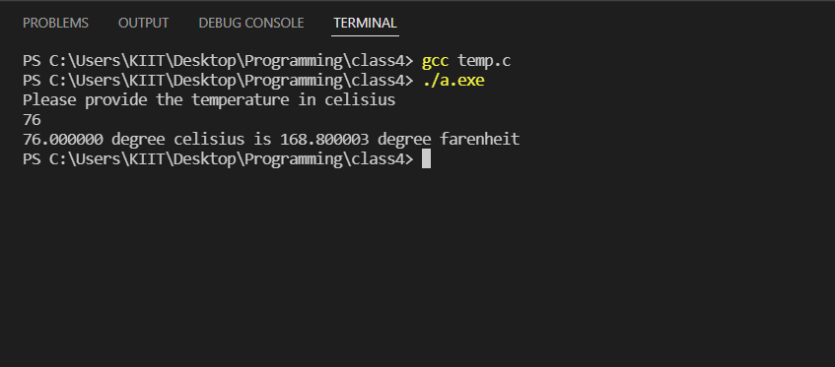

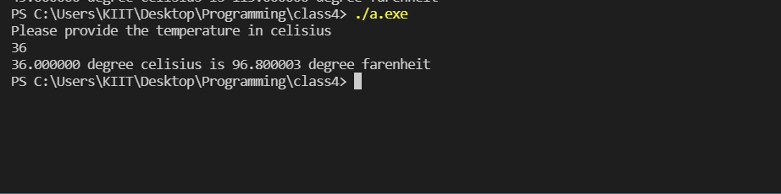

#3. WAP to calculate perimeter of a circle.
Code:
#include <stdio.h>
int main()
{
printf("give the radius of your circle:\n");
float rad426,per426;
scanf("%f",&rad426);
per426 = 3.14*rad426*2;
printf("The perimeter of your circle is %f",per426);
return 0;
}

Output:
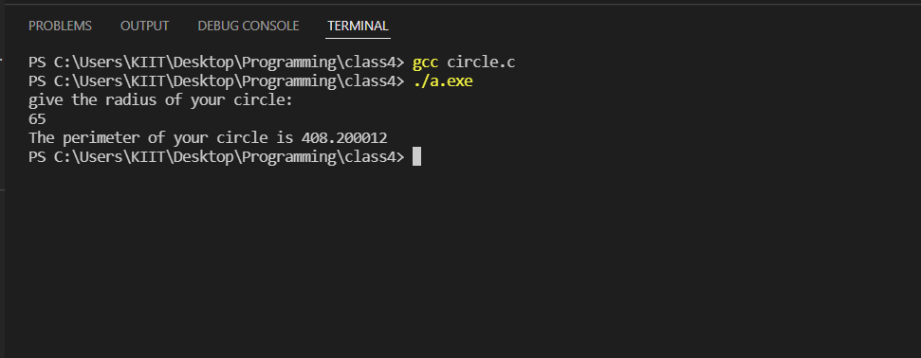

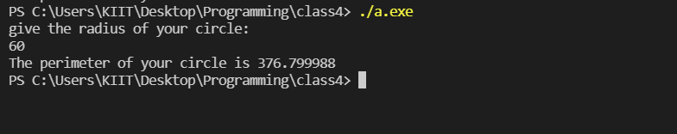

#4. WAP to find the smallest between two numbers.
Code:
#include <stdio.h>
int main()
{
printf("Provide the values you want to compare:\n");
float a426,b426;
scanf("%f%f",&a426,&b426);
if (a426<b426){
printf("The lesser number is %f",a426);
}
else{
printf("the lesser number is %f",b426);
}
return 0;
}

Output:
